# OpenCV Filters

## Gaussian

Probability theory is a part of mathematics that deals with random events within quantities. Within probability theory the “normal distribution” or Gaussian is when there is a “random” anomaly. However, a guy called Galileo Galilei, questioned it and found that this phenomenon was symmetrical around a central value.

### Gaussian Blur

Gaussian blur is a way of processing an image and blurring out any part of an image, usually to reduce the noise.

## Morphological Transformations

### Dilation

Dilation is when you take an image and brighten all the brighter parts of an image.

### Erosion

Erosion does the exact opposite and makes the image darker.

These can be used within images to reduce things such as reflections or bright lights in the background. While using erosion on a black and white image you can begin to define outlines of certain things see image below.

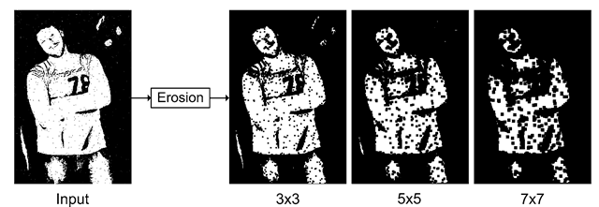

What-when-how, Unknown date.

Later we can use this to start doing edge detection called ‘boundary detection’ for example take the previous image and minus it from the input and we have our boundaries.

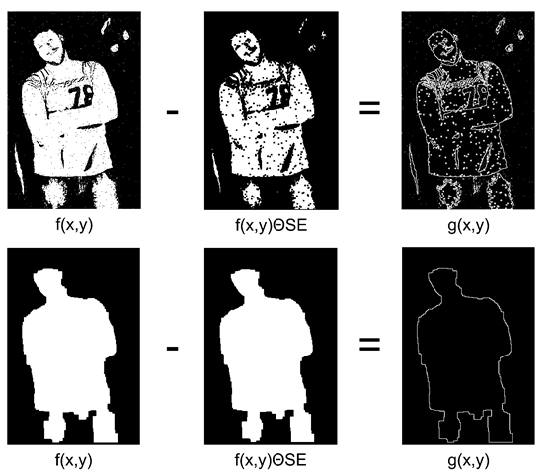

What-when-how, Unknown date.

# References

Siegmund, D.O., 2019. Probability theory [viewed 19/02/2019]. Available at: <https://www.britannica.com/science/probability-theory>

Gale, T., 2008. Normal Distribution [viewed 19/02/2019]. Available at: <https://www.encyclopedia.com/science-and-technology/mathematics/mathematics/normal-distribution#3>

What-when-how, Unknown. Morphology [viewed 19/02/2019]. Available at: <http://what-when-how.com/introduction-to-video-and-image-processing/morphology-introduction-to-video-and-image-processing-part-2/>